

ÇANKAYA UNIVERSITY

CENG 407 - Innovative System Design and Development I

Project title : LungXai

Authors
Orkun Oğuztürk-202111078
Can Berk Meşe-202111045
Ömer Faruk Şahin-202111073
Barbaros Murat Dönmez-202011019
Furkan Çoban-202011204
Arda Kaan Bakır-202111064

1. Introduction
Lung cancer remains the most frequently diagnosed malignancy and the leading cause of cancer related death worldwide. According to the World Health Organization, it accounts for nearly 1.8 million deaths in 2020 approximately one in five cancer fatalities[1]. Early detection through low dose computed tomography (LDCT) has significantly improved survival, as even small pulmonary nodules (<30 mm) can be detected in asymptomatic stages. Yet, radiologists face immense challenges: reviewing hundreds of CT slices per patient, differentiating between benign and malignant nodules with subtle appearance variations, and maintaining consistency across serial follow up scans.
Manual reading introduces subjective bias and inter observer variability, with reported discrepancies exceeding 20 % between readers in malignancy assessment tasks. Consequently, computer aided diagnosis (CAD) systems have been extensively researched to provide quantitative, reproducible, and explainable support for radiologists. Early diagnosis of lung cancer is critically important, as 5 year survival rates are significantly lower compared to other common cancers like breast and prostate cancer [3].
Early deep learning approaches applied 2D convolutional neural networks (CNNs) directly to individual CT slices, leveraging architectures such as VGG, ResNet, and DenseNet. These methods achieved strong per slice performance but lacked volumetric awareness, failing to account for spatial continuity across slices. In contrast, 3D CNNs capture full contextual information by convolving over volumetric data, yet they demand substantial computational resources and large annotated datasets.
To balance these tradeoffs, researchers introduced 2.5D architectures, a hybrid approach in which a stack of consecutive CT slices (typically 3 to 11) is treated as input channels to a 2D network. This configuration captures local 3D context while maintaining the computational efficiency of 2D convolutions. Studies demonstrated that 2.5D models yield comparable or superior performance to 3D CNNs, particularly for small datasets and limited hardware environments. For instance, a 2.5D DenseNet model showed superior overall performance and discrimination compared to a 3D DenseNet and a size based logistic model when differentiating invasive pulmonary adenocarcinomas, achieving a diagnostic performance comparable to that of thoracic radiologists [2]. The 2.5D DenseNet, in this study, also demonstrated significantly higher specificity (88.2%) at equally high sensitivities (90%) [2].

Despite remarkable algorithmic progress, medical imaging imposes domain constraints not present in natural image AI, including variability in voxel spacing and anisotropic resolution, the requirement for intensity normalization in Hounsfield Units, specialized DICOM and NIfTI data structures, and strict ethical, regulatory, and explainability obligations. These constraints necessitate specialized AI frameworks that combine medical data handling, standardized preprocessing, reproducibility, and deployment readiness. Furthermore, while CNN models have been effective in feature extraction, studies suggest that they may sometimes be insufficient in this process, leading to the development of hybrid models utilizing attention blocks to overcome these limitations [3].
Over the past five years, several frameworks such as MONAI, nnU-Net, and TorchIO have emerged. Among these, MONAI provides the most comprehensive ecosystem, covering the entire AI lifecycle from dataset preparation to model training, explainability visualization, and clinical deployment. Given these characteristics, this study exclusively employs MONAI to develop an explainable 2.5D deep learning framework for lung nodule malignancy classification. This choice ensures an end-to-end, standardized, and clinically translatable workflow that integrates seamlessly with medical data formats and radiology environments.

2. Previous Studies

2.1.1 Evolution of Deep Learning Architectures

Deep learning (DL) has fundamentally transformed medical image interpretation, replacing traditional radiomics pipelines that relied on handcrafted features with data driven Convolutional Neural Networks (CNNs). Early DL approaches utilized 2D CNNs, but these lacked volumetric awareness across contiguous CT slices [3]. This limitation led to the adoption of 3D CNNs as the standard for volumetric tasks like lung nodule detection. However, 3D convolution presents significant practical barriers, including cubic computational cost and the requirement for extensive annotated datasets, scaling poorly for large CT volumes [2].

To overcome the tradeoff between volumetric context and computational efficiency, researchers introduced 2.5D architectures. These models utilize a small stack of consecutive slices (multi-slice context) as input to a 2D network, effectively capturing local 3D context with reduced complexity [2]. Comparative analyses confirm the efficacy of this approach, showing that 2.5D DenseNet models can achieve a diagnostic performance comparable to that of thoracic radiologists [2]. Furthermore, a 2.5D DenseNet model demonstrated superior overall performance and discrimination, achieving a significantly higher Area Under the Curve (AUC) of 0.921 compared to a 3D DenseNet (AUC 0.835) and a size based logistic model (AUC 0.836) in differentiating invasive pulmonary adenocarcinomas [2]. The 2.5D approach also showed a high specificity of 88.2% at 90% sensitivity [2].

2.1.2 DL Performance Compared to Clinical Standards

Recent systematic reviews and meta analyses validate the superior performance of DL-based models in predicting the risk of malignancy in CT-detected pulmonary nodules compared to conventional clinical tools [6]. A comprehensive meta analysis across seventeen externally validated studies (comprising 9,884 nodules) yielded the following key findings [6]:
- DL vs. Physician Judgement: DL-based models demonstrated a 1.6% increase in sensitivity compared to physician judgement alone [6]. While specificity was similar (pooled DL specificity 0.77 vs. physician 0.81), DL models showed superior pooled AUC of 0.86 compared to physician readers alone (AUC 0.83) [6].
- DL vs. Clinical Risk Models: DL models were 14.5% more sensitive and 7.4% more specific than clinical risk models (such as the Brock and Mayo models) alone [6]. The pooled AUC for DL models (0.86) was significantly superior to clinical risk models (AUC 0.79) [6].
This evidence suggests that DL-based models, such as DenseNet-121, which achieved an accuracy of 90.39% and specificity of 93.65% in comparative studies, are already justified for routine deployment alongside experienced physicians [4, 6].

2.1.3 The Role of Nodule Context and Explainability
While CNNs are effective in feature extraction, studies indicate that high performance often relies on hybrid architectures and considering the nodule's surrounding environment [3, 5].
- Impact of Fibrotic Microenvironment: Novel research has demonstrated that incorporating the surrounding pulmonary context, particularly pulmonary fibrosis (fibrotic microenvironment), significantly improves nodule malignancy classification [5]. A 3D Attention Gated Network (3D AG-Net) trained with semantic fibrosis metadata achieved the best results with 80.84% accuracy and 0.89 AUC [5]. This study confirmed that models trained with both the nodule and its microenvironment outperformed models trained on the nodule alone, with the ability to detect malignant nodules increasing by 9.21% when fibrosis data was presented [5].

- Need for Hybrid Models and XAI: The conventional convolution process may be ineffective for feature extraction alone, leading to the development of hybrid models utilizing attention blocks to overcome these limitations [3]. Furthermore, studies focusing on Explainable AI (XAI) emphasize that predictive estimates are sometimes not understood or interpreted by clinicians [3]. The development of visualizable models, such as the 3D AG-Net, which uses attention gates to filter and visualize features at different network depths, provides crucial interpretability that is highly valued in clinical settings [5].
In conclusion, the literature points toward the efficacy of 2.5D and attention based architectures for achieving high performance with computational efficiency [2], and highlights the necessity of integrating these systems into a standardized, clinically translatable workflow (e.g., using frameworks like MONAI) that can handle complex data constraints and provide the required diagnostic accuracy and explainability [2, 6, 5].

2.1.4 Evolution of Research from Past to Present

The evolution of AI based approaches in lung cancer diagnosis has shown marked progress, moving from simple image processing techniques to today's complex, explainable, and clinically integrated systems. This developmental process can be read through the solutions generated for challenges such as hardware constraints, data complexity, and the need for clinical trust.

1. The Beginning and Limitations of Two Dimensional (2D) Approaches In the early era of deep learning in medical imaging, researchers primarily favored 2D Convolutional Neural Networks (CNNs), which had proven successful on natural images. These early approaches treated Computed Tomography (CT) slices as independent images, leveraging architectures such as VGG or ResNet. While these methods achieved strong feature extraction on a per slice basis, they suffered from a lack of "volumetric awareness" by ignoring the 3D structure of lung nodules and the spatial continuity across slices.

2. The Shift to 3D CNNs and the Computational Cost Problem The failure of 2D models to capture volumetric context led research directly toward 3D CNN architectures. These models managed to preserve spatial information by processing the entire volume of the nodule, improving detection accuracy. However, 3D convolution operations required immense computational power and GPU memory, and they necessitated significantly larger annotated datasets to train effectively. This emerged as a major barrier, limiting the practical applicability of 3D models and their scalability across different hardware environments.

3. Seeking Balance: The Rise of 2.5D Hybrid Architectures To strike a balance between computational efficiency and volumetric context, "2.5D" architectures were introduced. This approach relies on the strategy of stacking a small number of consecutive CT slices (multi slice context) to serve as input channels to a 2D network. Comparative analyses have demonstrated that this method effectively captures local 3D context without incurring the complexity of full 3D models. Particularly in environments with limited datasets and hardware, 2.5D models (such as 2.5D DenseNet) have been proven to yield comparable or superior discrimination and performance compared to full 3D models.

4. Beyond the Nodule: Environmental Context and Microenvironment As algorithmic improvements continued, researchers realized that focusing solely on the nodule was insufficient. Recent studies have revealed that the lung tissue surrounding the nodule (e.g., the fibrotic microenvironment) also holds diagnostic value. Hybrid structures and attention mechanisms that incorporate environmental data alongside the nodule have achieved higher success rates in malignancy detection compared to models trained on the nodule alone.

5. From Black Box to Explainable AI (XAI) Although AI models began to match or exceed the performance of clinicians, the lack of transparency in their decision making mechanisms (the black box problem) undermined clinical trust. Consequently, current research focuses not only on high accuracy but also on explainability. By integrating techniques such as Grad-CAM and attention gates into models, it has become possible to visualize exactly which regions the AI focuses on when making a decision. This transparency facilitates the validation of AI decisions by radiologists.

6. From Fragmented Tools to Unified Ecosystems (The Framework Revolution) In the final stage, the research focus has shifted from merely developing models to building sustainable and deployable systems. While fragmented libraries focusing on specific tasks (like nnU-Net or TorchIO) were used in the past, unified ecosystems like MONAI have now become the standard. These next generation frameworks standardize the entire process from data preprocessing to clinical deployment, enabling the seamless integration of academic work into hospital environments (such as PACS/OHIF systems) and ensuring the reproducibility of research.

2.2 Overview of Existing Frameworks

The nnU-Net framework introduced automated configuration for segmentation pipelines, standardizing preprocessing, architecture selection, and training parameters. It has achieved state of the art results in organ segmentation challenges but is task specific and lacks built in modules for classification, explainability, or deployment. Integrating nnU-Net into classification workflows typically requires additional frameworks.
TorchIO focuses on preprocessing and augmentation, enabling advanced data transformations such as elastic deformations, bias field simulation, and random noise. Although highly useful for dataset preparation, TorchIO does not provide model architectures, evaluation metrics, or deployment infrastructure.
Both nnU-Net and TorchIO contribute valuable utilities; however, they function as partial solutions. In contrast, MONAI integrates all essential components of medical AI development within a single coherent ecosystem. For a project that aims to progress from research to clinically usable outcomes, such integration ensures maintainability, reproducibility, and compliance with hospital IT standards.

2.3 MONAI: The Unified Medical AI Ecosystem

The Medical Open Network for AI (MONAI), founded jointly by NVIDIA and King’s College London, represents a purpose built ecosystem for medical imaging research and deployment. It is fully open source (Apache 2.0 license) and implemented in Python using the PyTorch backend. MONAI’s modular architecture consists of several tightly integrated subsystems.
The monai.transforms module provides domain specific image transformations, including intensity normalization, resampling, cropping, random affine transformation, and Gaussian noise addition. The monai.networks library contains deep learning architectures optimized for medical imaging, such as DenseNet, UNet, AttentionUNet, and SwinUNETR, supporting 2D, 2.5D, and 3D inputs. The monai.metrics module implements standardized evaluation metrics including Dice coefficient, Hausdorff distance, AUC, and FROC. The monai.inferers package enables efficient sliding window and patchbased inference for large 3D volumes, while monai.visualize provides utilities for Grad-CAM, feature maps, and training visualizations. Finally, monai.apps includes pre trained models and ready to use pipelines for segmentation, classification, and detection tasks.
MONAI’s data pipeline supports flexible input dimensionality. Through its composable transforms, multiple adjacent CT slices can be concatenated along the channel dimension to simulate a 2.5D stack. The framework’s CacheDataset and SmartCacheDataset classes allow efficient on thefly augmentation of slice groups, while sliding_window_inference enables inference on large 3D scans by processing 2.5D patches sequentially—an efficient hybrid strategy between 2D and 3D.
Furthermore, MONAI provides native support for explainable AI via Grad-CAM and Integrated Gradients, allowing visualization of malignancy driving regions directly on CT slices. Combined with MONAI Deploy, these outputs can be packaged into deployable clinical applications with DICOM-compatible interfaces.
Unlike modular utilities such as TorchIO or nnU-Net, MONAI enables end to end workflow management from preprocessing to inference within one standardized environment. This eliminates compatibility issues between libraries, reduces code redundancy, and ensures complete traceability for regulatory audits. Therefore, the current study exclusively adopts MONAI for all stages of development[7].

Framework Comparison
MONAI — nnU-Net — TorchIO

Criterion | MONAI | nnU-Net | TorchIO
Goal | An end to end framework for medical imaging and deep learning. | Self adapting automatic segmentation system. | A library for medical image preparation and augmentation.
Input Formats | DICOM, NIFTI, PNG, JPG, 3D volumetric data. | NIFTI heavy. | NIFTI, DICOM, etc.; focus: preprocessing.
Preprocessing Features | Medical image normalization, spacing adjustment, intensity transforms, lung windowing, DenseNet support. | Automatic voxel spacing adjustment, normalization, resampling. | Built in loading, non rigid transforms, random intensity, bias field noise, elastic deformation.
Model Architecture | Systems supporting 2D / 3D U-Net, SegResNet, DenseNet, Swin-UNETR, Vision Transformer based systems. | 2D/3D UNet/3D cascade UNet automatic configuration. | Model is robust, users add their own models.
Core Feature | Education - Assessment - XAI - Inference - Clinical deploy pipeline. | Automatic hyperparameter selection and preprocessing. | Modern augmentation and data pipeline control.
2D-3D Support | Native 2D and 3D pipeline. | 2D, 3D, 3D cascade. | 2D & 3D
Explainability (XAI) | GRAD-CAM, IG, SHAP integration. | Not natively present; external. | No
Annotation / GUI | MONAI Label (3D Slicer / OHIF support). | No annotation support. | Annotation support.
Hospital / PACS Integration | Yes (MONAI Deploy DICOM, HL7, FHIR). | No | No
Flexibility | Segmentation + classification + detection + registration. | Only segmentation. | Preprocessing library for every model type.
Optimization Strategy | Customizable loss functions, mixed precision, distributed training. | Fully automatic model selection and hyperparameter optimization. | Data pipeline acceleration (patch based training support).
Advantage | Complete ecosystem supporting research to clinical deployment. | SOTA benchmark in segmentation. | Ready made modern medical augmentation set.
Limitation | High learning curve. | Preprocessing and segmentation only. | Does not include model training.

2.4 Commercial Clinical AI Systems

Clinical deployment has been exemplified by Qure.ai and Optellum. Qure.ai’s qCT-LN Quant automates volumetric nodule quantification and serial growth tracking, integrating into PACS and providing structured reports. Optellum’s Virtual Nodule Clinic specializes in malignancy risk stratification, offering dashboards with color coded risk scores and follow up management tools[8][9].
Both systems are FDA-cleared, but their proprietary architectures prevent academic reproducibility. These products illustrate the importance of combining high algorithmic performance with interpretability and workflow usability core design principles also emphasized in our system.

Commercial System Comparison
Qure.ai — Optellum Virtual Nodule Clinic
Criterion | Qure.ai | Optellum Virtual Nodule Clinic
Medical Use Area | Automatic findings and reports for Chest X-ray and brain CT. | Malignancy risk assessment of lung nodules.
Data Input | X-ray, CT. | CT (thorax).
Output Structure | Automatic report draft, finding annotation, heatmap. | Nodule based risk score, case management panel.
Clinical Workflow Model | Triage + automatic reporting. | Risk stratification + clinical decision support.
Interface | Report editor + visual finding annotation. | Nodule list + malignancy risk matrix + follow up plan.
Performed Task | Automatic writing of findings, decision acceleration. | Clinical probability support for nodule malignancy.
Decision Authority | Physician approved AI recommendation. | Multidisciplinary team assessment.
Most Prominent Feature | Automatic radiology report generation. | Nodule malignancy scoring and patient specific risk planning.
Strength | Operational speed and report standardization. | Risk modeling close to clinical decision.
Limitation | Not focused on nodule based malignancy. | Area of operation is lung nodules only.

3. Research Questions and Approach
Q1. Why is a 2.5D hybrid MONAI approach preferred over purely 2D or 3D CNN architectures?
2D models require significantly less GPU memory and offer faster training times, making them ideal for limited computational environments. However, they lack volumetric contextual awareness.
3D models process entire volumes, improving spatial understanding but demanding large VRAM and prolonged training.
A 2.5D hybrid approach implemented in MONAI provides the optimal balance stacking multiple consecutive CT slices as input channels to a 2D CNN. This configuration captures local 3D context while maintaining training efficiency.

Q2. Which deep learning architectures are most suitable for segmentation and classification tasks in lung nodule malignancy assessment?
- For segmentation, architectures such as SegResNet and UNet demonstrate robust performance, efficient training, and high reproducibility.
- For classification, DenseNet121 and ResNet50 are recommended due to fast convergence, stable gradients, and integrated Grad-CAM explainability support.
- Advanced networks such as EfficientNet-B0, DynUNet, and Swin-UNETR can be explored in later phases for improved feature extraction and accuracy.
- A hybrid ensemble (ResNet + EfficientNet + DenseNet) may be adopted to combine performance and interpretability.

Q3. How will Explainable AI (XAI) techniques be implemented within the system?
The system will integrate Grad-CAM, Integrated Gradients, and LIME through MONAI’s monai.visualizemodule.
These methods generate slice wise heatmaps that highlight malignancy driving regions, ensuring transparency and supporting radiologists in understanding the AI’s decision making process.
By visualizing these regions directly on CT slices, the system ensures clinical trust and compliance with explainable medical AI standards.

Q4. How do hardware limitations affect model selection, training, and evaluation strategies?
Under limited GPU resources, training begins with UNet or SegResNet for segmentation and DenseNet121 for classification to ensure fast prototyping.
Once initial results are validated, heavier architectures like DynUNet or Swin-UNETR will be deployed in the high performance stage.
This staged approach balances computational efficiency and accuracy while maintaining XAI compatibility.
All experiments are optimized with mixed precision and CacheDataset usage to reduce training time without compromising reproducibility.

4. Proposed Contributions
- Implementation of a fully explainable 2.5D MONAI-based deep learning pipeline for lung nodule malignancy classification.
- Integration of Grad-CAM visualization for per slice interpretability in both training and inference stages.
- Comparative analysis of 2D, 2.5D, and 3D CNN architectures under identical conditions to evaluate computational efficiency and diagnostic accuracy.
- Development of an open, reproducible pipeline compatible with 3D Slicer / OHIF Viewer for real time clinical interaction.
- Creation of an ensemble based classification framework combining ResNet, EfficientNet, and DenseNet for improved robustness.

5. Methodology and Algorithms

5.1. Our Difference
Existing literature reveals two persistent limitations: the lack of open, unified frameworks that support end-to-end 2.5D medical imaging pipelines with built in explainability, and the absence of clinically oriented, reproducible AI systems that can transition seamlessly from research to hospital environments.
This study proposes a 2.5D explainable deep learning framework for lung nodule malignancy classification built exclusively within MONAI. The system leverages MONAI’s modular infrastructure to implement the entire workflow from DICOM input to Grad-CAM-based visualization without external dependencies.
Data preprocessing is implemented with monai.transforms, including intensity normalization (HU scaling from -1000 to 400 HU), resampling to isotropic 1 mm voxels, and channel wise stacking of 5 to 9 adjacent slices for 2.5D representation. The model architecture is a modified DenseNet121 adapted for 2.5D input channels, initialized with ImageNet weights via MONAI’s model zoo. The training strategy employs patch based sampling using CacheDataset for performance optimization, stochastic augmentations such as flipping, affine transformations, and elastic deformations, and balanced sampling of benign versus malignant nodules. Explainability is achieved through Grad-CAM integrated via monai.visualize. CAM, generating slice wise heatmaps that highlight malignancy related regions. Evaluation metrics include ROC-AUC, accuracy, precision, recall, and FROC sensitivity at 1 FP/scan, computed using monai.metrics.
Through MONAI Label, the model can be deployed directly into 3D Slicer or OHIF Viewer, allowing radiologists to upload CT series, review AI generated heatmaps, and receive malignancy probability scores per nodule. The interface mirrors the functionality of Optellum’s Virtual Nodule Clinic while remaining fully open source and customizable.
Structured reports are automatically generated summarizing nodule coordinates, volume, malignancy probability, and volume doubling time (VDT). Follow up recommendations are provided according to Fleischner guidelines, facilitating multidisciplinary decision support.
The system follows a human in the loop paradigm, where AI acts as a decision support tool rather than a diagnostic authority. All model decisions are explainable and subject to radiologist confirmation, ensuring alignment with medical AI ethics and fostering clinical trust.
This work demonstrates a reproducible 2.5D explainable pipeline entirely within MONAI, eliminating dependence on fragmented external libraries. It provides an open, extensible template for other medical imaging tasks requiring 2.5D contextual learning and bridges academic research with clinical applicability by uniting performance, interpretability, and deployment readiness.

5.2. Dataset Description: LIDC-IDRI

The Lung Image Database Consortium and Image Database Resource Initiative (LIDC-IDRI) dataset is one of the most comprehensive publicly available lung CT datasets used for pulmonary nodule classification and malignancy assessment. The dataset contains 1,018 patient studies, each including a full chest CT scan stored in DICOM format, along with XML-based annotations provided by four experienced thoracic radiologists.

Each study contains:
• 40–300 axial CT slices, typically reconstructed at 2.5 mm spacing
• A corresponding XML annotation file describing all nodules
• Consensus and individual markings from four radiologists

5.2.1. Nodule Annotations
Radiologists independently annotated each CT volume and provided:
• Nodule contours (per slice)
• 3D centroid coordinates (x, y, z)
• Malignancy score (1–5 scale)
• Additional characteristics (texture, margin, sphericity, etc.)

Nodules are categorized into:
• Nodules ≥ 3 mm
• Nodules < 3 mm (usually excluded from deep learning tasks)
For this project, nodules ≥ 3 mm are used due to clear radiological visibility.

5.2.2. Malignancy Label Distribution
The malignancy score in LIDC-IDRI ranges from 1 to 5:
• 1–2 → benign
• 3 → indeterminate
• 4–5 → malignant

Typical dataset wide distribution (based on widely cited statistics):
• Benign (1–2): ~45%
• Indeterminate (3): ~30%
• Malignant (4–5): ~25%

Since “3” represents diagnostic uncertainty, these samples are excluded in many classification studies (including our study) to avoid label noise and improve binary classification performance.
After removal of malignancy score 3, the dataset typically yields:
• Benign: ~60–65%
• Malignant: ~35–40%

5.2.3. Number of Nodules
Across the 1,018 patients, the dataset contains:
• 2,669 annotated nodules ≥ 3 mm
• Each nodule appears in multiple slices across the z-axis
• On average, 1–4 nodules per patient
In our project, each nodule contributes one 2D slice (the centroid slice) and a 128×128 or 64×64 crop centered on the nodule.

5.2.4. Slice and Patch Generation for This Study
To adapt the dataset for a 2D classification model:
1. The centroid z-slice is selected for each nodule.
2. A centered crop (64×64 or 128×128) is extracted around (cx, cy).
3. HU normalization is applied (−1000 to 400 → scaled to 0–1).
4. One image corresponds to one nodule instance.

This results in:
• One training sample per nodule
• Fully balanced benign/malignant subsets possible via augmentation

On average, the working dataset after preprocessing yields:
• ~1,500–1,700 patches (depending on exclusions)
• Binary labels: benign (0) and malignant (1)
This format is appropriate for MONAI’s 2D classification models.

5.2.5. Rationale for Using LIDC-IDRI
The LIDC-IDRI dataset is chosen due to:
• Comprehensive radiologist annotations
• Public availability and reproducibility
• Strong benchmarking presence in lung cancer AI literature
• Compatibility with both 2D and 3D workflows
It is considered the de-facto standard for pulmonary nodule classification and XAI experiments.

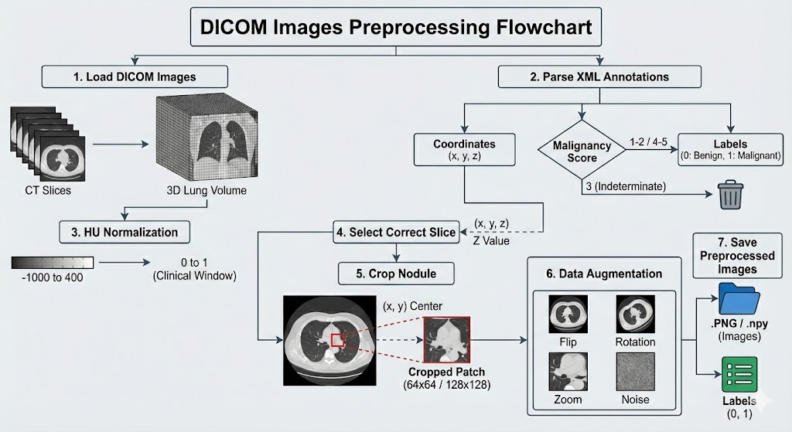
5.3 DICOM Images Preprocessing Flowchart

Title: Figure Y: Data Preprocessing Pipeline for Lung Nodule Detection

Text: "The data preprocessing pipeline consists of seven sequential steps designed to prepare raw medical data for deep learning models:

Load DICOM Images: Raw CT slices are loaded from the dataset to construct a complete 3D lung volume for each patient.

Parse XML Annotations: Annotation files are parsed to extract nodule center coordinates (x, y, z) and malignancy scores. Scores of 1-2 are labeled as Benign (0), scores of 4-5 are labeled as Malignant (1), and indeterminate scores (3) are discarded to reduce label ambiguity.

HU Normalization: Hounsfield Unit (HU) values are normalized using a clinical lung window range of [-1000, 400]. The intensity values are then scaled to the [0, 1] range for numerical stability.

Select Correct Slice: The specific 2D axial slice containing the nodule is identified and selected using the extracted Z-coordinate.

Crop Nodule: A square patch (e.g., 64x64 or 128x128 pixels) centered on the nodule is cropped from the selected slice using the (x, y) coordinates to focus on the Region of Interest (ROI).

Data Augmentation: To prevent overfitting and improve model generalization, augmentation techniques such as Flip, Rotation, Zoom, and Noise injection are applied to the training data.

Save Preprocessed Images: The final processed patches and their corresponding labels are saved in .png or .npy (NumPy array) formats, creating the final dataset ready for training."

5.4 Pipeline
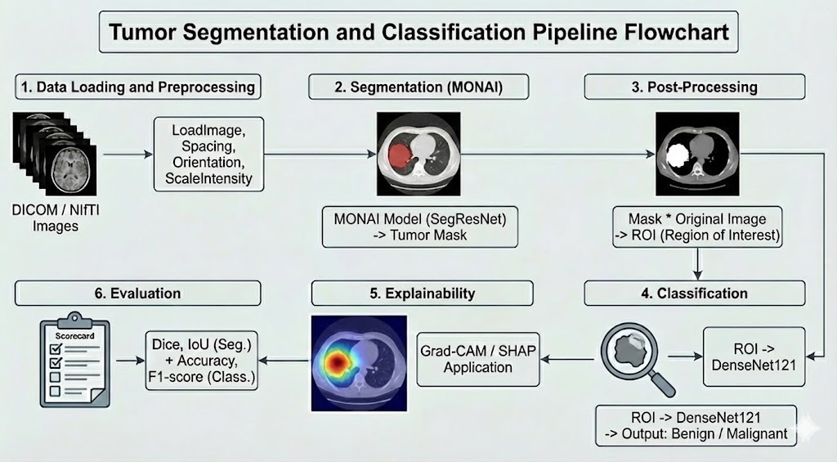
1. Data Loading and Preprocessing: Raw images in DICOM and NIfTI formats are loaded into the system. The data is standardized for model training by applying LoadImage, Spacing (voxel resizing), Orientation, and ScaleIntensity (intensity scaling) transforms using the MONAI library.

2. Segmentation (SegResNet): Preprocessed images are fed into the SegResNet architecture for the detection of the tumor region. At this stage, the model generates a binary mask that delineates the tumor boundaries within the lung image.

3. Post Processing: The generated segmentation mask is applied to the original image via element wise multiplication to eliminate background noise. Thereby, a Region of Interest (ROI) containing solely the tumor tissue is obtained.

4. Classification (DenseNet121): The resulting ROI images are used as input for the DenseNet121 model. The model analyzes these focused images to classify the tumor as either Benign or Malignant.

5. Explainability (XAI): Grad-CAM and SHAP techniques are employed to ensure the transparency of the model's decision making mechanism. This allows for the visualization (via heatmaps) of the specific tumor regions the model focuses on when making a prediction.

6. Evaluation: Model performance is evaluated in two stages. Segmentation performance is measured using Dice Score and IoU, while classification performance is assessed using Accuracy and F1-Score metrics.

5.5 Algorithms
Stage | Algorithm / Framework | Purpose and Description
Preprocessing | monai.transforms – HU normalization, resampling  (1 mm³), slice stacking | Standardizes CT volumes, converts DICOM to 2.5D slice groups.
Segmentation | UNet, SegResNet | Extracts nodule masks and defines  regions of interest for classification.
Classification | DenseNet121, ResNet50, EfficientNet-B0 | Predicts malignancy from segmented  nodules; supports Grad-CAM XAI.
Hybrid & Ensemble | Combination of ResNet + EfficientNet + DenseNet | Integrates multiple feature extractors  for improved reliability.
Explainability | Grad-CAM, Integrated Gradients, LIME  (via monai.visualize) | Provides interpretable heatmaps and  highlights malignancy regions.
Training Strategy | CacheDataset, Mixed Precision, Balanced Sampling | Reduces memory load and stabilizes  learning under limited resources.
Evaluation Metrics | ROC-AUC, Accuracy, Precision, Recall, FROC @ 1 FP/scan | Ensures quantitative and clinical  reliability of model predictions.

6. Expected Results and Evaluation Plan
The proposed 2.5D MONAI-based model is expected to achieve:
- Robust classification and detection performance on the LIDC-IDRI dataset, demonstrating the ability to identify nodules and differentiate between benign and malignant cases in a manner consistent with expert radiologist assessments.
- Interpretable visual explanations through Grad-CAM or similar techniques, highlighting regions of interest in alignment with radiologist annotations to support transparency and trust in clinical decision making.
- Improved computational efficiency compared to traditional 3D CNN approaches, potentially reducing training time and GPU memory usage, facilitating faster experimentation and deployment in resource constrained environments.
- A comprehensive end to end deployment workflow via MONAI Deploy, generating structured malignancy reports and visual overlays that can be readily reviewed by clinicians and integrated into existing radiology pipelines.
- A functional and user friendly interface that allows clinicians to easily access, interact with, and interpret model outputs, enhancing the practical integration of the AI tool into daily clinical workflows.

References
[1] https://www.who.int/news-room/fact-sheets/detail/lung-cancer
[2] Kim, H., Lee, D., Cho, W.S. et al. CT-based deep learning model to differentiate invasive pulmonary adenocarcinomas appearing as subsolid nodules among surgical candidates: comparison of the diagnostic performance with a size-based logistic model and radiologists. Eur Radiol 30, 3295–3305 (2020). https://doi.org/10.1007/s00330-019-06628-4
[3] Canayaz, M., Şehribanoğlu, S., Özgökçe, M. et al. A comprehensive exploration of deep learning approaches for pulmonary nodule classification and segmentation in chest CT images. Neural Comput & Applic 36, 7245–7264 (2024). https://doi.org/10.1007/s00521-024-09457-9
[4] Saied, M., Raafat, M., Yehia, S. et al. Efficient pulmonary nodules classification using radiomics and different artificial intelligence strategies. Insights Imaging 14, 91 (2023). https://doi.org/10.1186/s13244-023-01441-6
[5] Liu, Y., Hsu, H.Y., Lin, T. et al. Lung nodule malignancy classification with associated pulmonary fibrosis using 3D attention-gated convolutional network with CT scans. J Transl Med 22, 51 (2024). https://doi.org/10.1186/s12967-023-04798-w
[6] Wulaningsih, W., Villamaria, C., Akram, A. et al. Deep Learning Models for Predicting Malignancy Risk in CT-Detected Pulmonary Nodules: A Systematic Review and Meta-analysis. Lung 202, 625–636 (2024). https://doi.org/10.1007/s00408-024-00706-1
[7] https://github.com/Project-MONAI/MONAI
[8] https://www.qure.ai/
[9] https://optellum.com/

